Migration Document for Receipt Creation Process.
Step 1: Login to the Database System.
Step 2: Create a table for errors. Run the following script
Step 3: Run the script to create package specification and package body.
Specification | Body

Step 4: Login to the EBS Application.
Responsibility: Application Developer > Press CTRL + L > Search for Lookup > Select Application Object Library
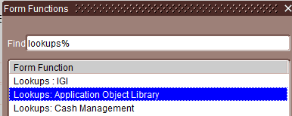
Create the Lookup XXAU_UNIT_CASH_CLEARING for the following records.
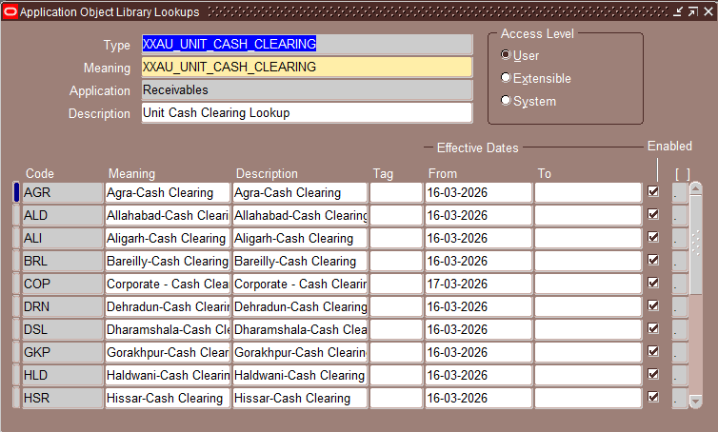

Step 5: Create a Concurrent Program and Executable with
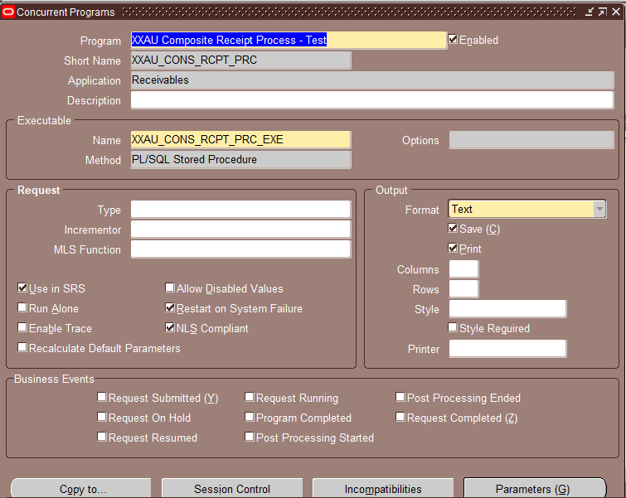
Program Name: XXAU Composite Receipt Process – Test
Short Name: XXAU_CONS_RCPT_PRC
Application: Receivables
Executable: XXAU_CONS_RCPT_PRC_EXE
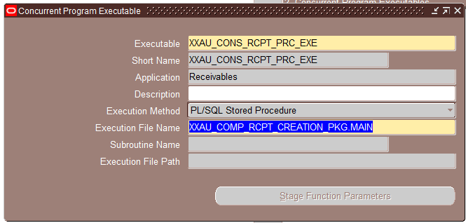
Executable: XXAU_CONS_RCPT_PRC_EXE
Executable short Name: XXAU_CONS_RCPT_PRC_EXE
Application: Receivables
Execution Method: PL/SQL Stored Procedure
Execution File Name: XXAU_COMP_RCPT_CREATION_PKG.MAIN
Step 6: Register it to Request Group
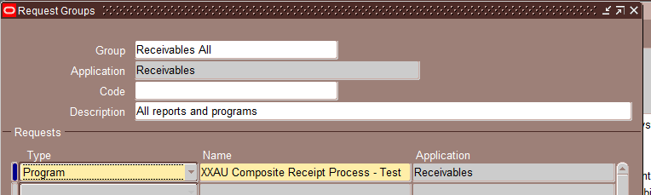
Group: Receivables All
Application: Receivables
Step 7: Run the Program from the AUPL Receivable Managers or from Receivable Manager. View Output will contain the Receipt Numbers that has been created.
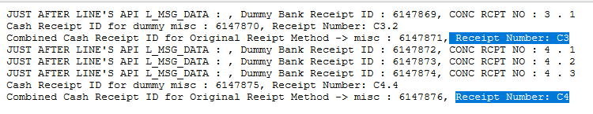
Step 8: Check the Created Receipts After completion of the program.
These are the Combined Receipts and the Receipt Number present in the Comment section are the Dummy Receipts.
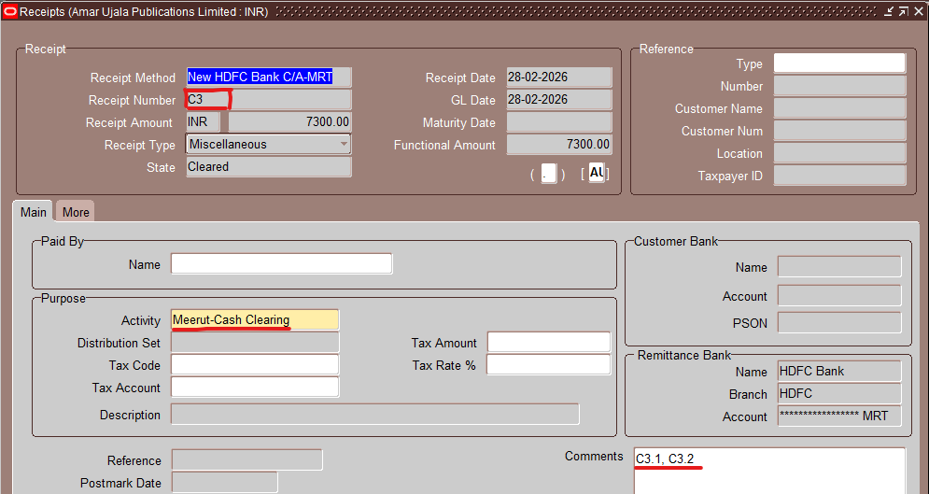
The following is the dummy receipt ‘C3.1’. The comments part is showing it’s Composite Receipt Number.
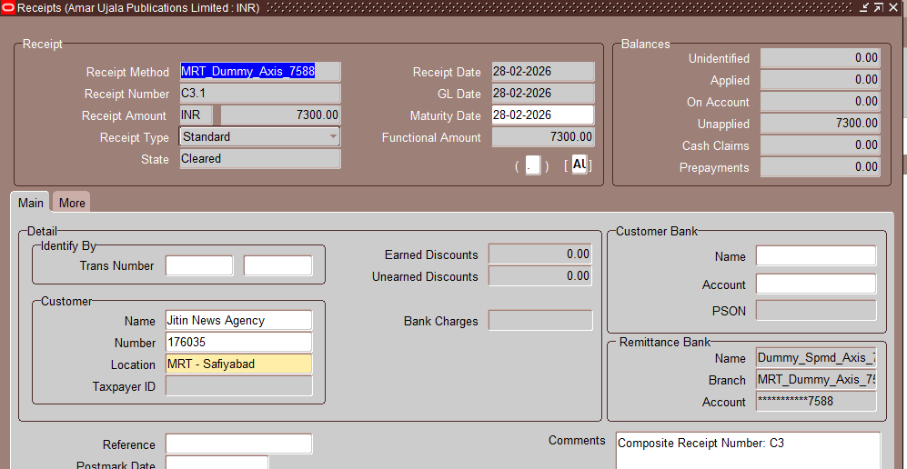
The Receipt Number: C3.2, this is the Miscellaneous Receipt of the Composite Receipt with Negative amount, Cash Clearing activity and Dummy Bank.
